Scientific Calculator
Mini Project Report
Yash Sameer Parande
MT2025135

Project Overview

Introduction
This report describes the design and implementation of a deployment pipeline for a Scientific Calculator application developed using Java. The project illustrates the full software development process, incorporating practices such as continuous integration, automated testing, containerization with Docker, and deployment using infrastructure-as-code techniques.
Repository: https://github.com/parandeyash-sys/Mini-Project-SPE
Docker Hub : https://hub.docker.com/repository/docker/yash140603/scientific-calculator/general
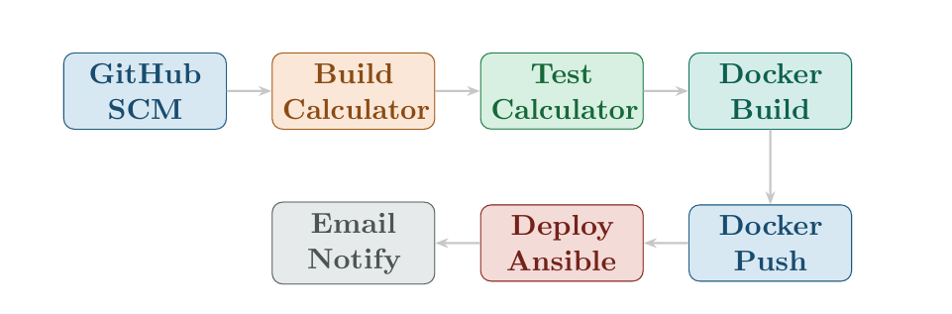

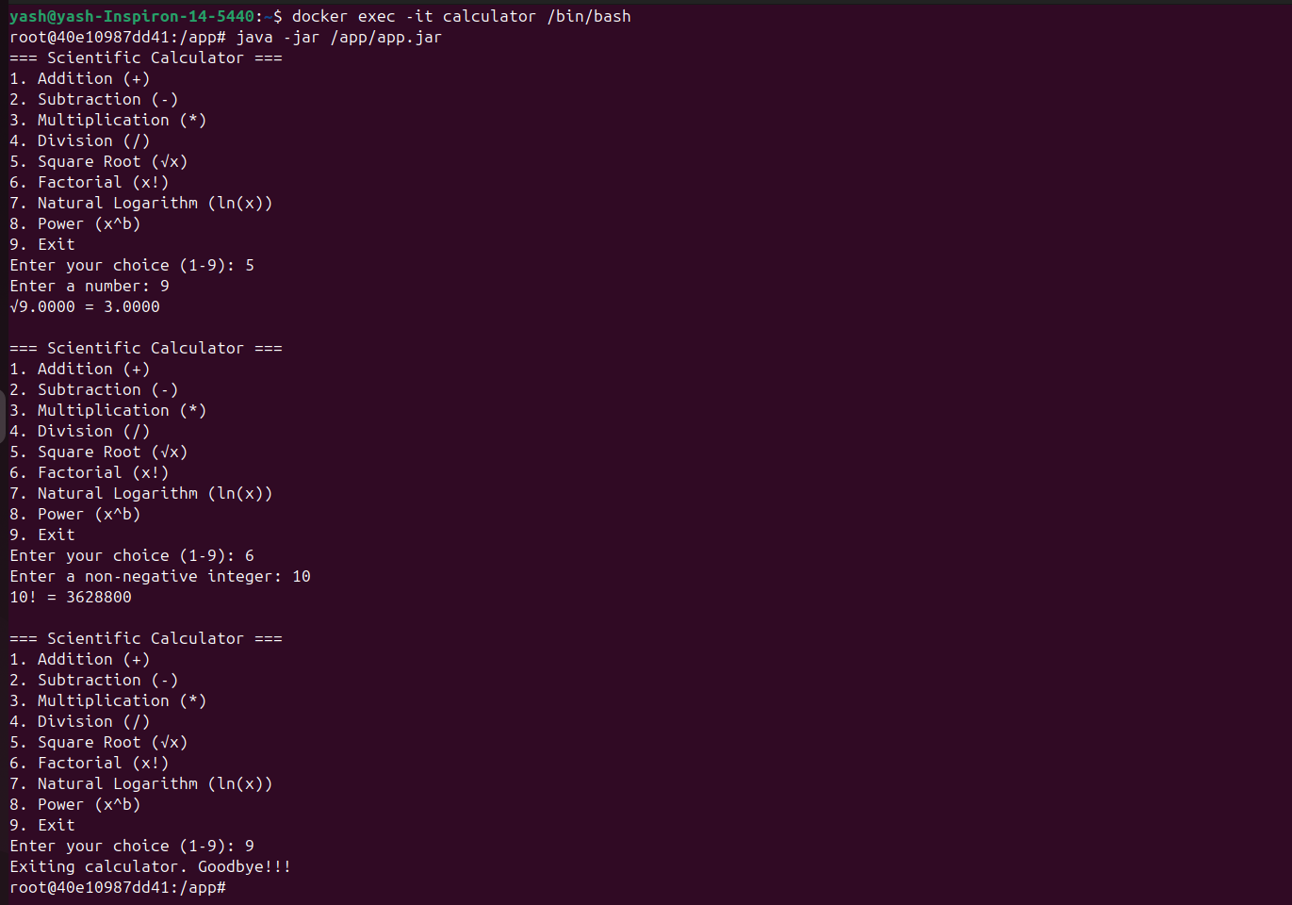
Figure 1: Scientific Calculator Application in Terminal

Tech Stack & Objectives
Stack: Java, Maven, JUnit, Jenkins, Docker, Ansible
Application: Command-line scientific calculator with basic arithmetic (add, subtract, multiply, divide) and advanced functions (square root, factorial, logarithm, power) with comprehensive error handling.

Jenkins Pipeline Architecture

Pipeline Overview
The Jenkins pipeline automates the complete build, test, and deployment workflow. It follows a clarity and maintainability.

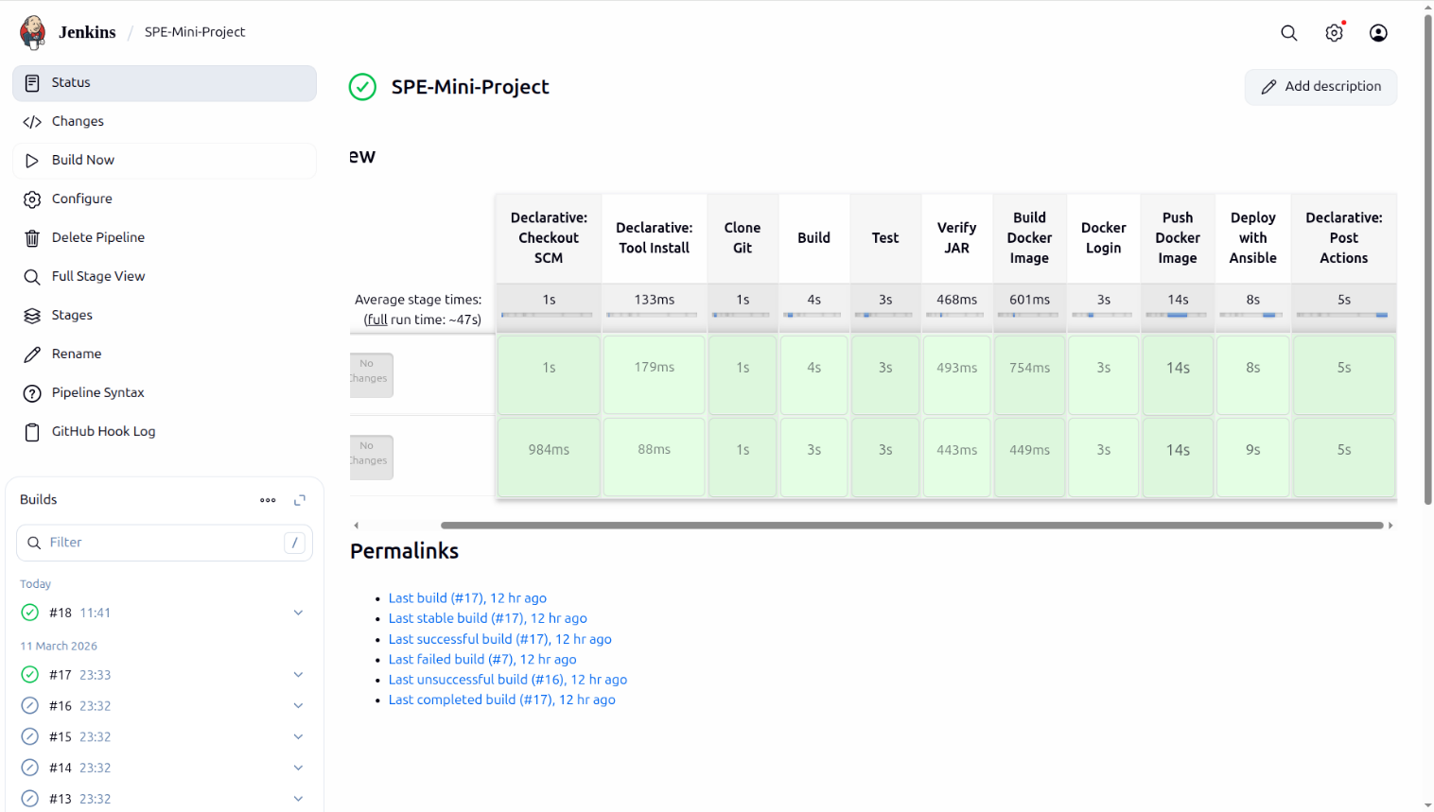
Figure 2: Jenkins Pipeline Architecture

Ngrok: Exposing Jenkins to GitHub Webhooks
Jenkins typically runs on a local development system, which means it cannot be accessed directly from the internet. To solve this, ngrok is used to establish a secure public tunnel that connects the local Jenkins server to the outside network. This allows GitHub webhooks to reach Jenkins and automatically trigger the pipeline whenever new code is pushed to the repository.

How It Works
- Jenkins runs on the local machine and is accessible at http://localhost:8080.

- ngrok is started to create a secure public URL that tunnels traffic to the local port (for example, https://unfended-unexhibited-jude.ngrok-free.app → localhost:8080).

- This ngrok address is then configured as a GitHub Webhook in the repository under Settings → Webhooks, with the Payload URL pointing to the generated ngrok link.

- When a new commit is pushed to the main branch, GitHub sends an HTTP POST request to the webhook endpoint.

- The request passes through ngrok, which forwards it to the local Jenkins server, causing the configured pipeline job to start automatically.

Key Benefits in This Project
No external server needed: The entire CI/CD workflow can run directly from a local machine, eliminating the need for a cloud-based Jenkins server.
Fast feedback cycle: Each time code is pushed to the Git repository, the pipeline automatically performs the build, testing, containerization, and deployment steps within a short time.
Protected connection: ngrok creates a secure HTTPS tunnel with TLS encryption, ensuring that GitHub webhooks can safely communicate with the local Jenkins server.
Minimal setup effort: Running a simple command like ngrok http 8080 quickly exposes the local Jenkins service to the internet, making the configuration easy and lightweight.

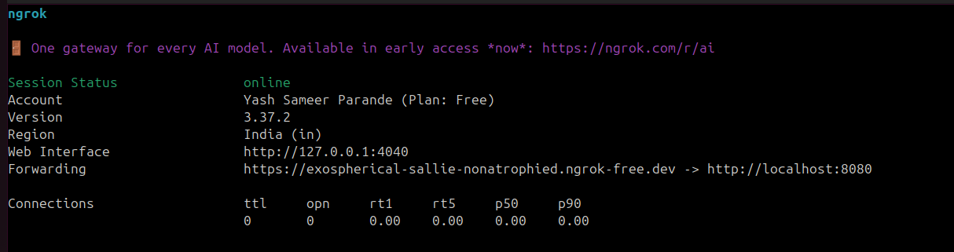
Figure 3: ngrok Tunnel Exposing Local Jenkins to the Internet

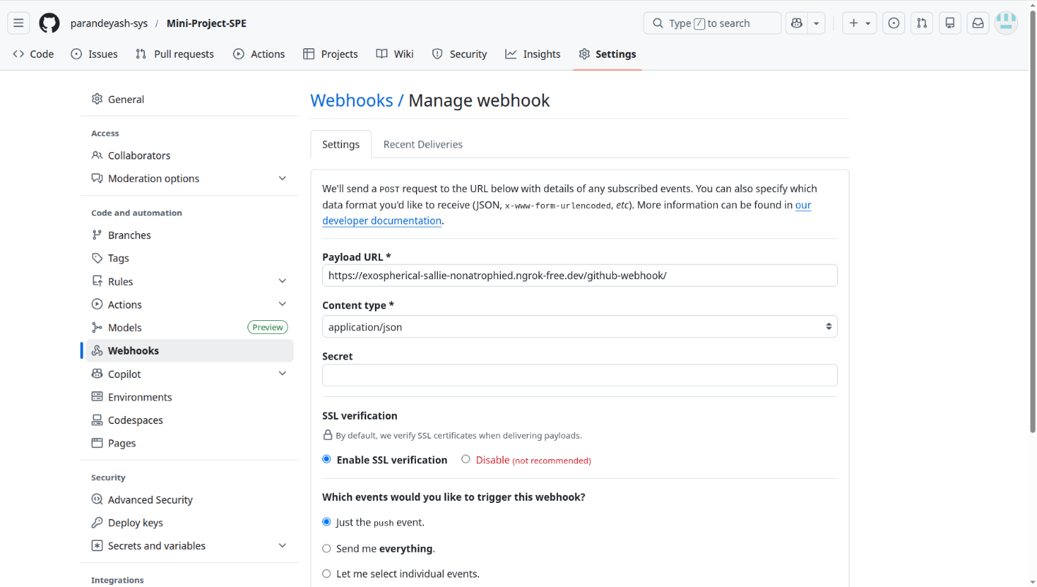
Figure 4: GitHub Webhook Configured with ngrok URL

Pipeline Stages

Stage 1: Clone Git
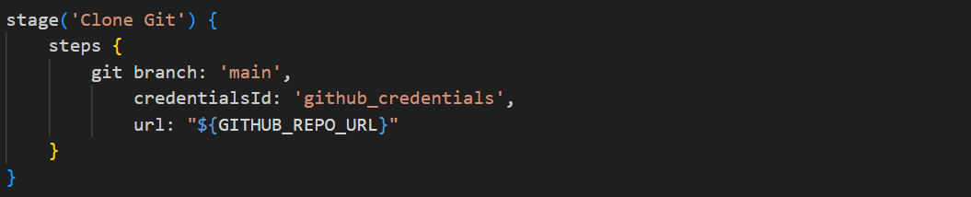

Listing 1: Clone Git Stage
Purpose: Fetches latest source code from GitHub. Authenticates to repository and provides clean workspace for builds.

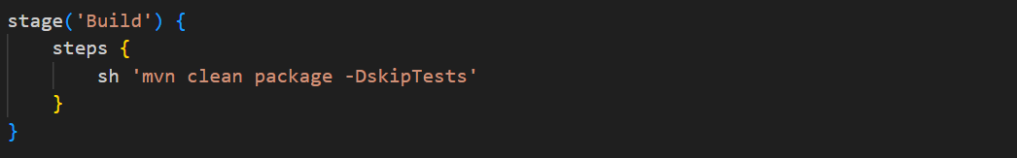
Stage 2: Build
Listing 2: Build Stage

Purpose: Compiles Java source and creates JAR artifact. Tests are skipped here and executed in the Test stage.

Stage 3: Test
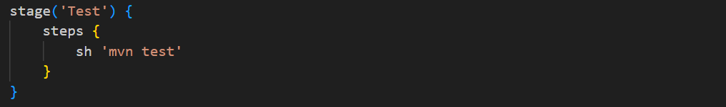
Listing 3: Test Stage
Purpose: Executes 47 comprehensive unit tests using JUnit 5 and generates test reports.

Stage 4: Verify JAR Existence
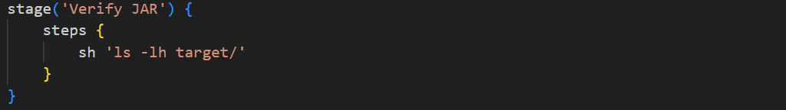

Listing 4: Verify JAR Existence Stage
Purpose: Verifies successful JAR creation by listing target directory contents.

Stage 5: Build and Push Docker Image
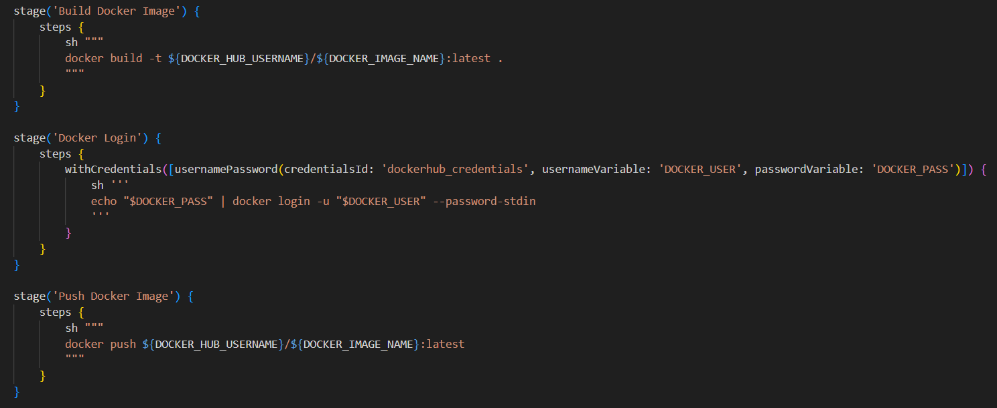

Listing 5: Docker Build Stage (Partial)
Purpose: Builds and pushes multi-platform Docker images (linux/amd64, linux/arm64) to Docker Hub registry.

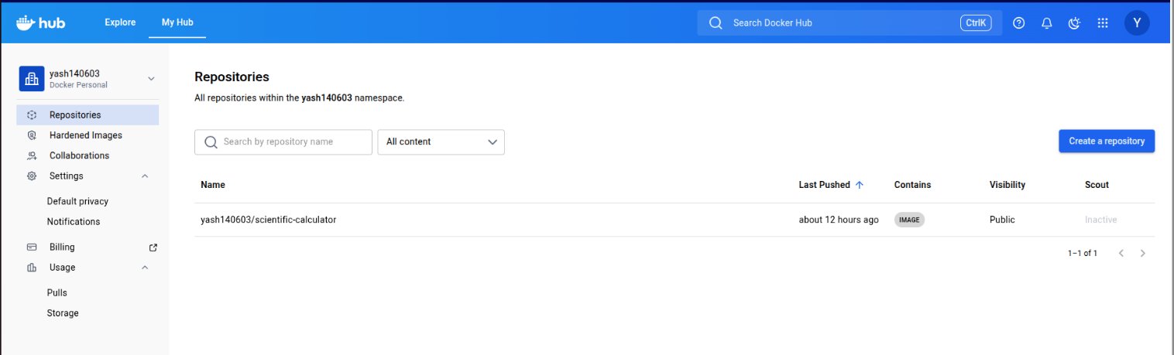

Figure 5: Docker Hub Multi-Platform Build

Stage 6: Deploy with Ansible
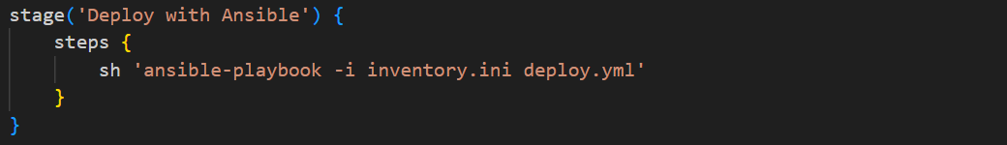
Listing 6: Ansible Deployment Stage
Purpose: Automates application deployment to target servers using Ansible playbooks.

Figure 6: Container Running and Deployed

Environment Variables
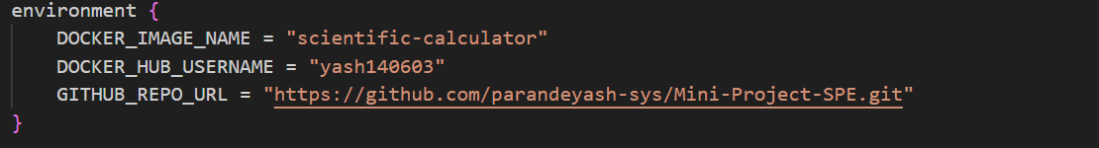
Listing 7: Environment Configuration
These variables configure: Docker image name, GitHub repository URL, Docker Hub credentials, and Docker daemon socket.

Testing and Validation

Test Suite Overview
The project includes 47 comprehensive unit tests covering all calculator operations. Tests are organized using JUnit 5’s annotation-based approach.

Test Coverage

Mathematical Operations Tested
Square Root: Positive numbers, zero, decimals, negative numbers
Factorial: Zero, one, positive integers (up to 20)
Natural Logarithm: One, Euler’s number, positive values, zero, negative values
Power Operations: Base cases, decimal exponents, edge cases

Test Sample
Tests validate: Square Root (√16 = 4, √0 = 0), Factorial (0! = 1, 5! = 120, 20! = 2.4 10¹⁸),
×
Natural Logarithm (ln(1) = 0, ln(e) = 1). Edge cases include NaN handling for negative numbers and infinity for ln(0). All 47 tests execute in 41 milliseconds with 100% pass rate.

Deployment Configuration

Dockerfile
The Dockerfile defines the container image used to package and run the Scientific Calcu- lator application.
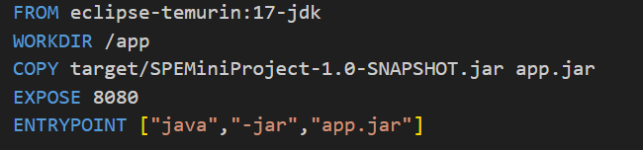
Listing 8: Dockerfile

Dockerfile Breakdown
Base Image (FROM openjdk:17.0.1-jdk-slim): This instruction selects a compact OpenJDK 17 slim image as the base layer. It provides the required Java environment while keeping the overall container image small and efficient.
Working Directory (WORKDIR /app): Defines /app as the default directory inside the container. All commands executed afterwards will run from this location, ensuring a consistent and organized workspace.
Copy JAR (COPY): Transfers the compiled Maven JAR file SPEMiniProject-1.0-SNAPSHOT.jar into the container. The file is renamed to app.jar to make it easier to reference during execution.
Entry Point (CMD ["/bin/sh"]): Launches a shell when the container starts. This allows the user to manually run the application inside the container using the command java -jar app.jar.
This image is built for multiple platforms (linux/amd64 and linux/arm64) using Docker
Buildx in the Jenkins pipeline and published to Docker Hub under yash140603/scientific-calculator:

Ansible Deployment Playbook (deploy.yml)
The deploy.yml file automates container deployment to target servers using Ansible or- chestration.

Playbook Structure
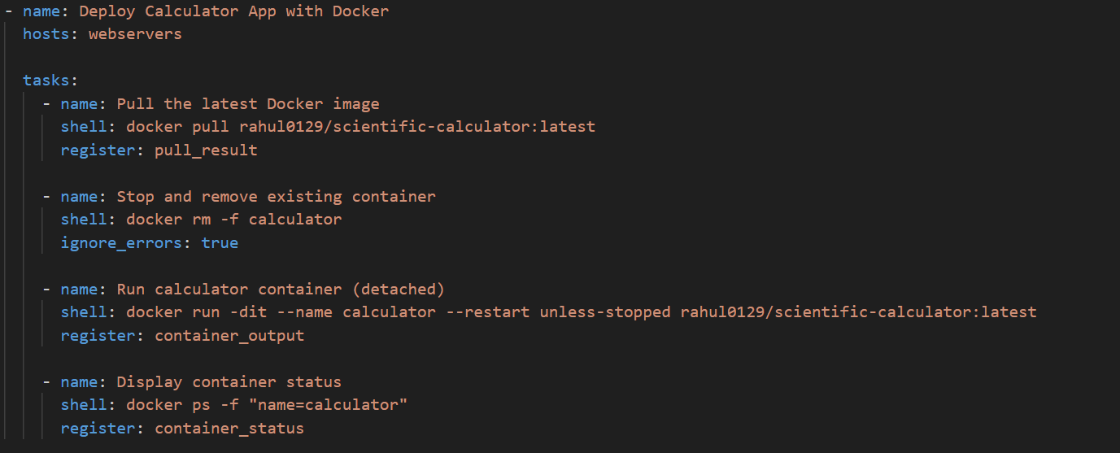

Listing 9: deploy.yml Tasks

Key Operations
Pull Image: Downloads latest Docker image from Docker Hub
Cleanup: Removes existing container (non-blocking with ignore errors)
Deploy: Launches container in detached mode with auto-restart policy
Verify: Confirms successful container deployment and status
This playbook targets webservers host group defined in inventory.ini, enabling cen- tralized deployment across multiple servers.

Pipeline Execution Flow
The Jenkins pipeline runs step-by-step across six stages: Clone (retrieves the source code), Build (compiles the project using Maven), Test (executes 47 JUnit 5 tests), Verify (confirms the JAR file is generated), Containerize (creates a multi-platform Docker image), and Deploy (uses Ansible to release the application).

Quality Assurance & Benefits
QA Measures: Reliability is maintained through automated testing with 47 test cases, build validation, cross-platform testing, and Infrastructure-as-Code based deployment processes.
Benefits: The system provides full automation, uniform behavior across environments, the ability to scale to multiple servers, strong portability across different CPU architectures, and quick feedback with test execution taking around 41 ms.

Conclusion
This project effectively illustrates the implementation of a complete CI/CD pipeline, achieving full test reliability with 47 out of 47 tests passing, rapid execution time of about 41 ms, and multi-platform Docker containerization. The automated workflow incorporates Git-based source control, Maven-driven Java builds, extensive JUnit 5 testing, Docker image creation and publishing for multiple platforms, and deployment through Ansible automation. Together, these components highlight modern DevOps methodologies, integrating continuous integration, automated verification, and infrastructure-as-code practices to ensure a reliable and efficient software delivery process.

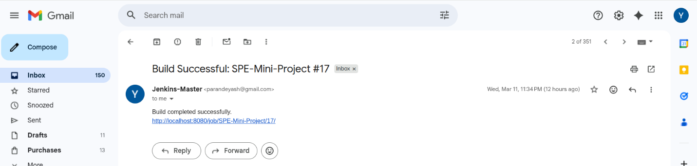

Figure 8: Email Notification on Build Status

